

Static Website

on

**“Deploying a Static Website using AWS”**

**TABLE OF CONTENTS**

1. Introduction

2. Advantages of Hosting Website on S3

3. Prerequisites

4. Architecture Overview

4.1 - Amazon S3

4.2 – Static Website Hosting on Amazon S3

5. Steps for Deployment

Step 1: Create an S3 Bucket

Step 2: Upload Content of your Website in the Bucket

Step 3: Make Objects Public using ACL

Step 4: Enable Website Hosting

Step 5: Access Your Website.

6. Conclusion

7. References

**1. INTRODUCTION**

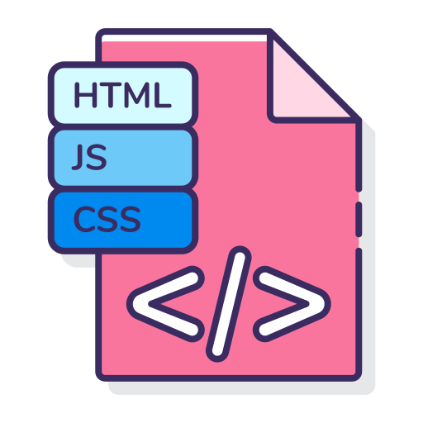A website is considered static when all the web pages and scripts are rendered on the client side rather than the server side. In contrast, a dynamic website relies on server-side processing, using server-side scripts such as PHP, JSP, or ASP.NET.

Nowadays, many websites are becoming static, meaning they don't run any server-side code and consist solely of HTML, CSS, and JavaScript. Since there is no server-side code to execute, these websites don't need to be hosted on a traditional server.

To set up a static website, you can start by creating an Amazon S3 bucket. Enable the Amazon S3 Website hosting feature and configure the access permissions for the bucket. Once you have uploaded your files and set up the website, Amazon S3 will handle serving your content to visitors.

**2. ADVANTAGES OF HOSTING WEBSITE ON S3**

**Performance:**

The website will be highly performant and scalable at a fraction of the cost of a traditional Web server.

**Scalability:**

Amazon S3 is inherently scalable. For popular websites, the Amazon S3 architecture will scale seamlessly to serve thousands of HTTP requests per second without any changes to the architecture.

**Availability:**

In addition, by hosting with Amazon S3, the website is inherently highly available.

**3. PREREQUISITIES**

An AWS Account

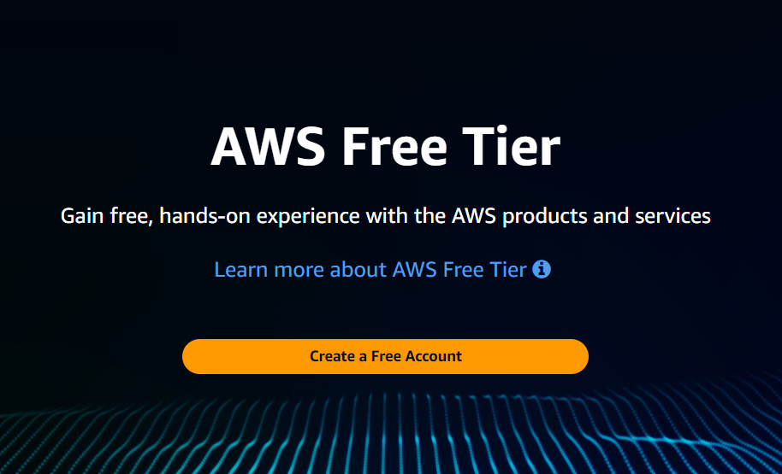

**4. ARCHITECTURE OVERVIEW**

**4.1**

**AMAZON S3**

Amazon S3 (Simple Storage Service) is a scalable and secure object storage service by Amazon Web Services (AWS). It offers:

**Scalability:** Virtually unlimited data storage.

**Durability and Availability:** 99.999999999% durability and 99.99% availability.

**Security:** Encryption, fine-grained access controls, and IAM integration.

**Cost-Effectiveness:** Pay-as-you-go pricing with various storage classes.

**Flexibility:** Stores any type of data and integrates with other AWS services.

**Performance:** Low latency and high throughput.

**Ease of Use:** Simple web interface, APIs, and SDKs.

S3 is ideal for website hosting, backups, data archiving, big data analytics, and more.

**4.2**

**Static Website Hosting on Amazon S3**







Amazon S3 Bucket

Static Website Hosting

HTML, CSS, Java, Images

User Access Site

**5. STEPS FOR DEPLOYMENT**



**STEP 1 :**

**Create an S3 Bucket**

**Search for S3**

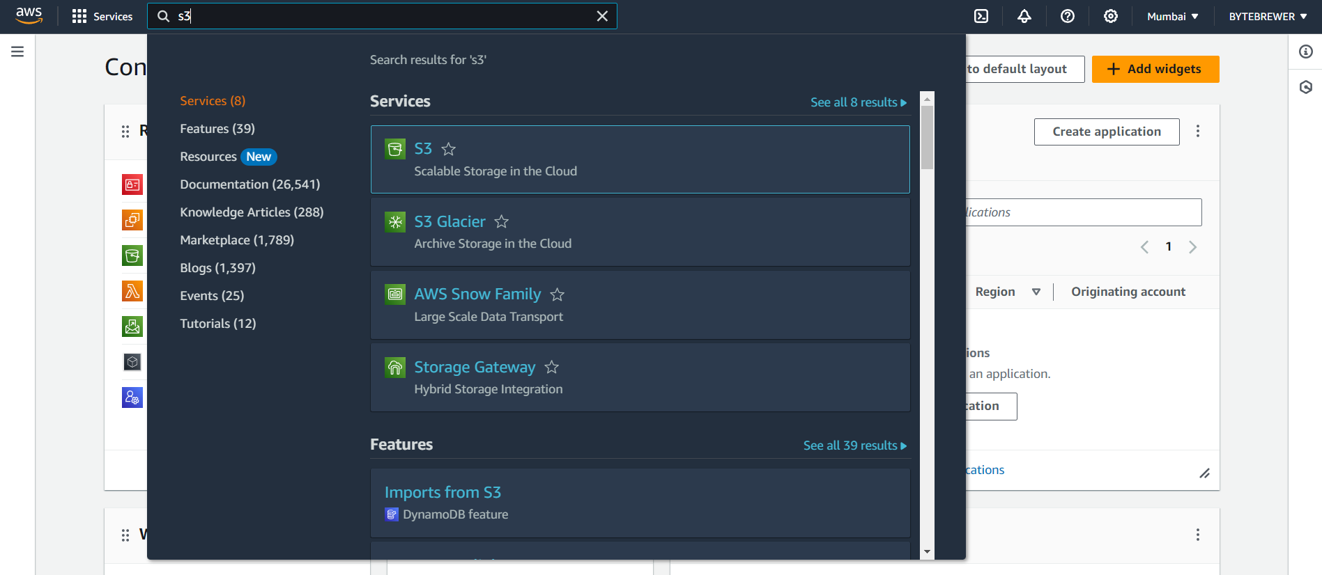



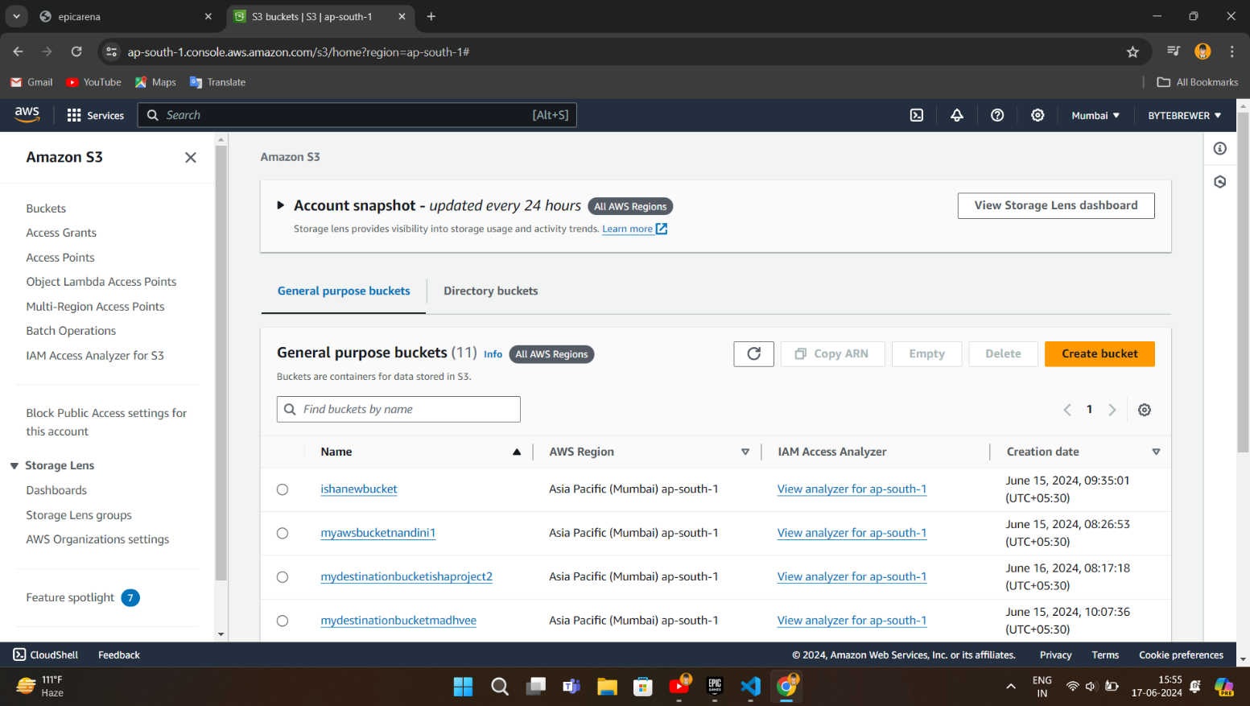





Click here to create a bucket

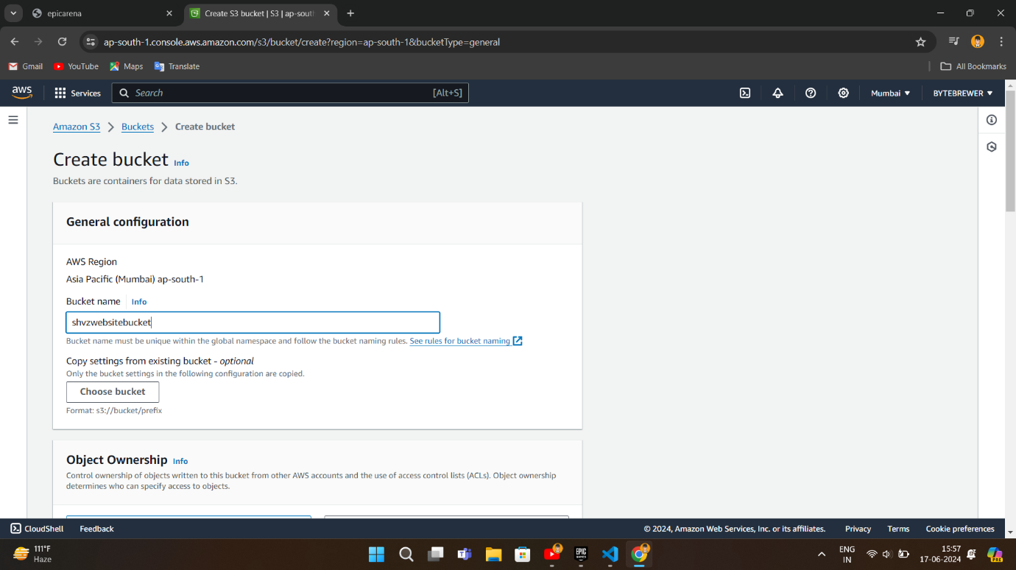

Provide a globally unique name for bucket

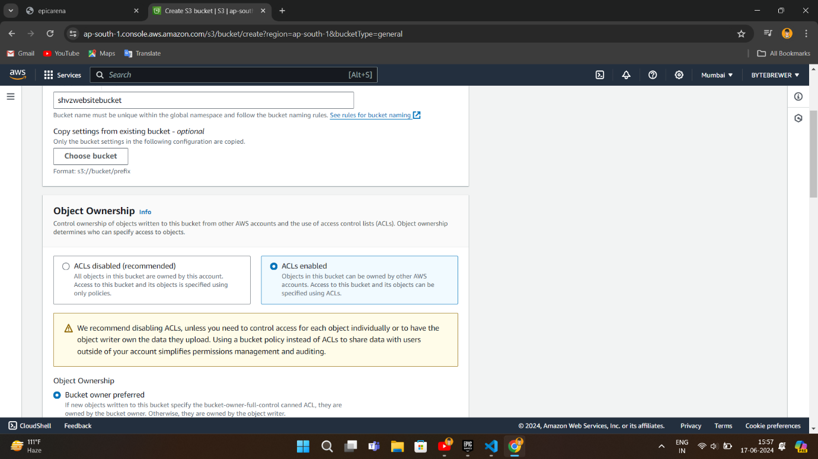

Click on ACLs enabled



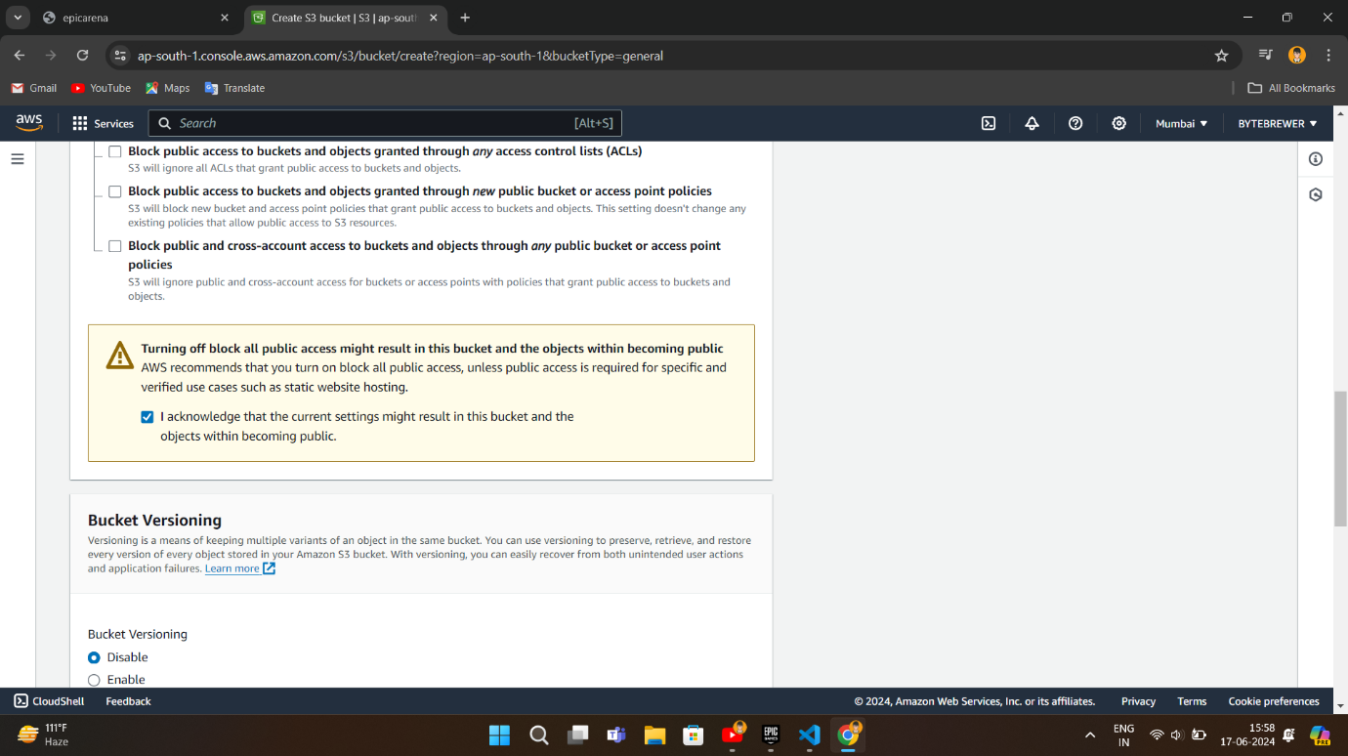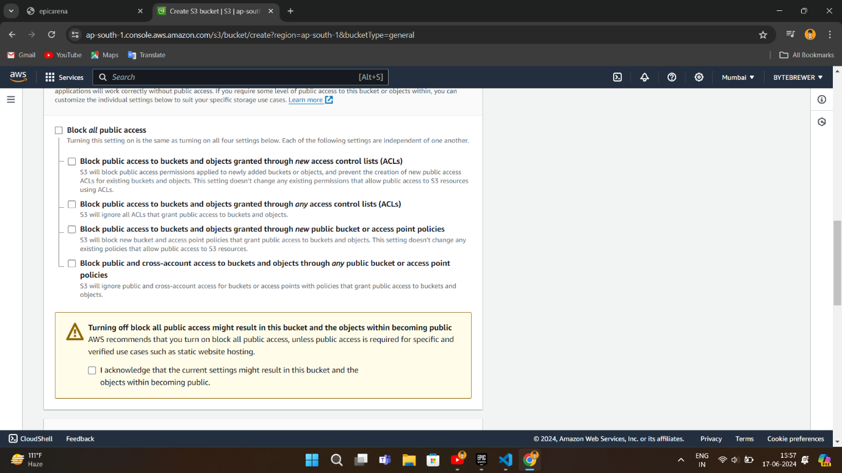

**UNCHECK** “Block all public access”

**Click on** “**I Acknowledge current settings**” **and Leave the Remaining settings on DEFAULT**



**Click on**

**create bucket**

**STEP 2 :**

**Upload Content of your Website in the Bucket**

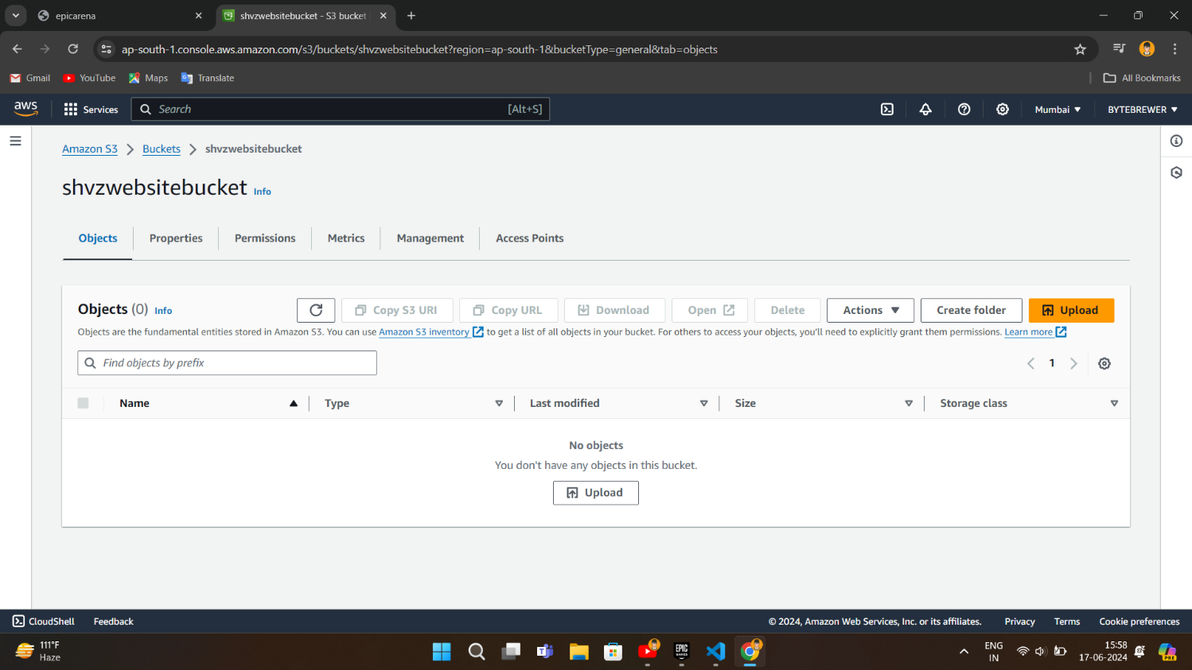

Example:

* Index.html
* Images
* css

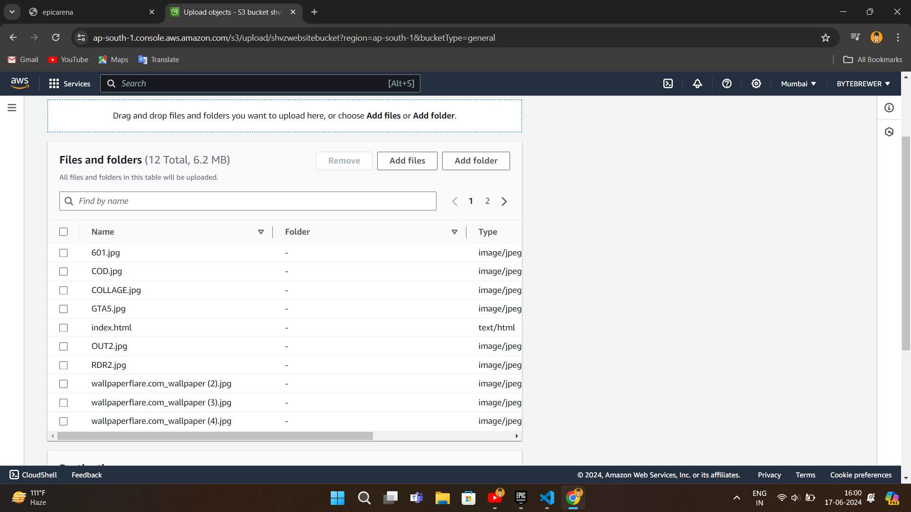

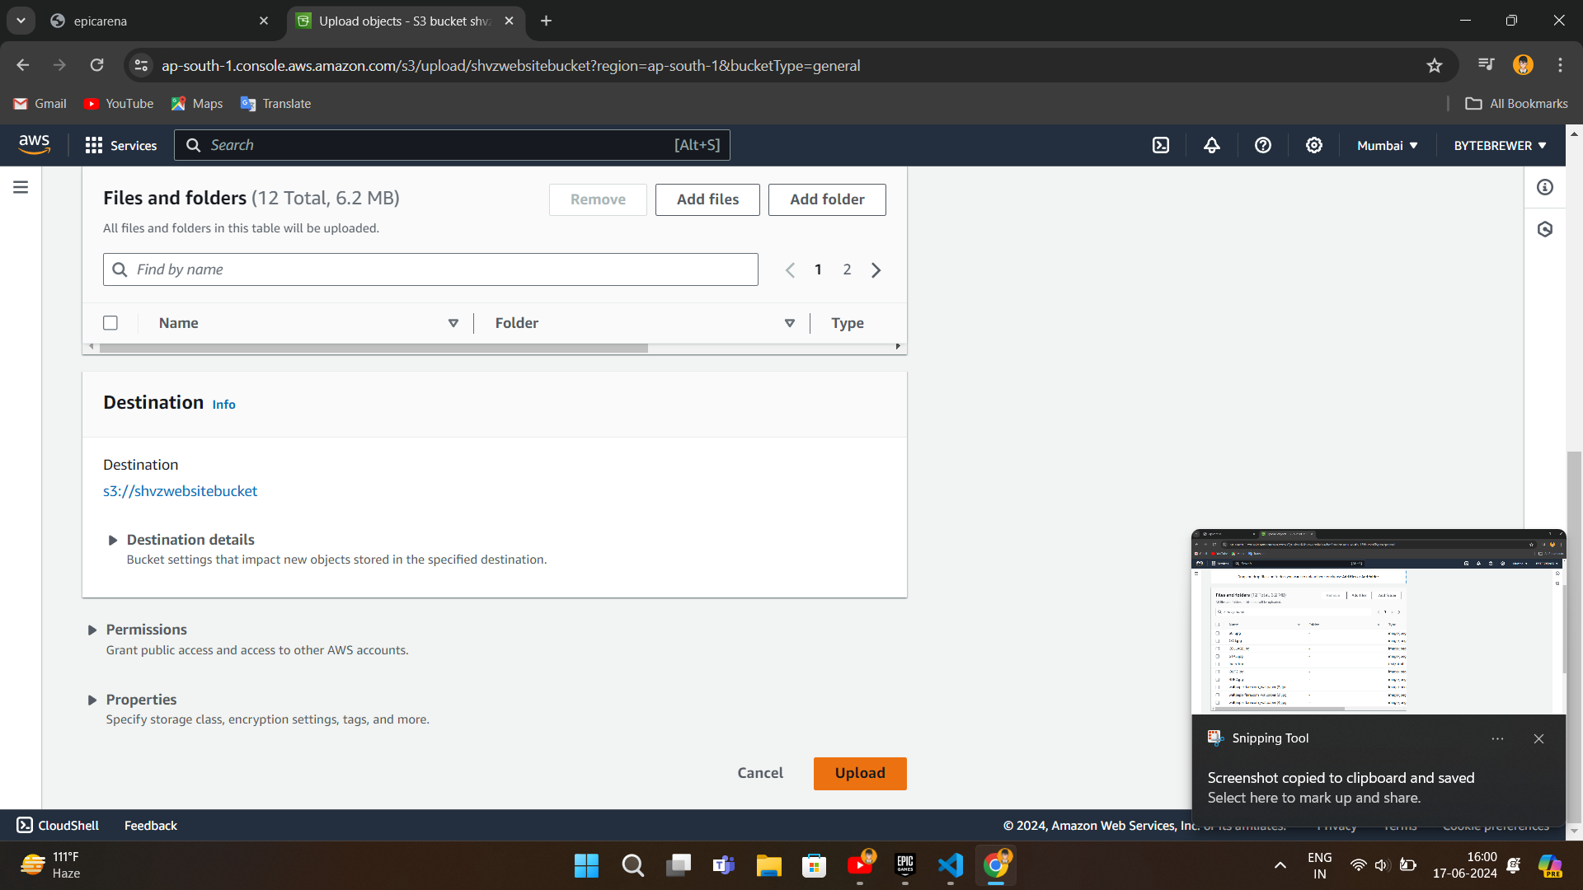

**STEP 3 :**

**Make Objects Public using ACL**

Select all the Object Present in Bucket and Make Them Public using ACL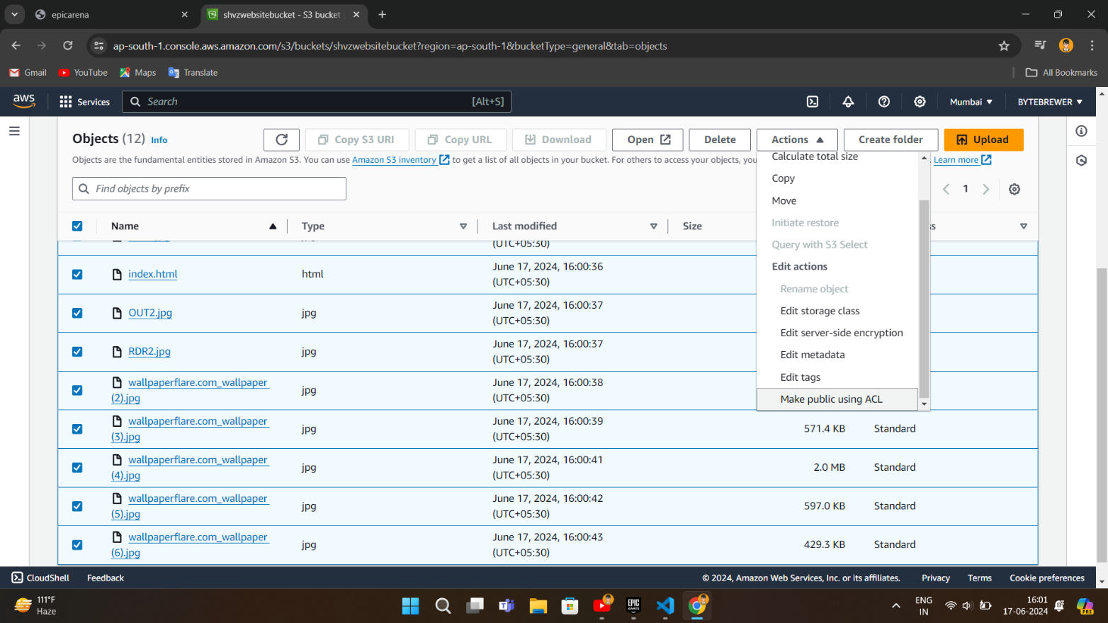

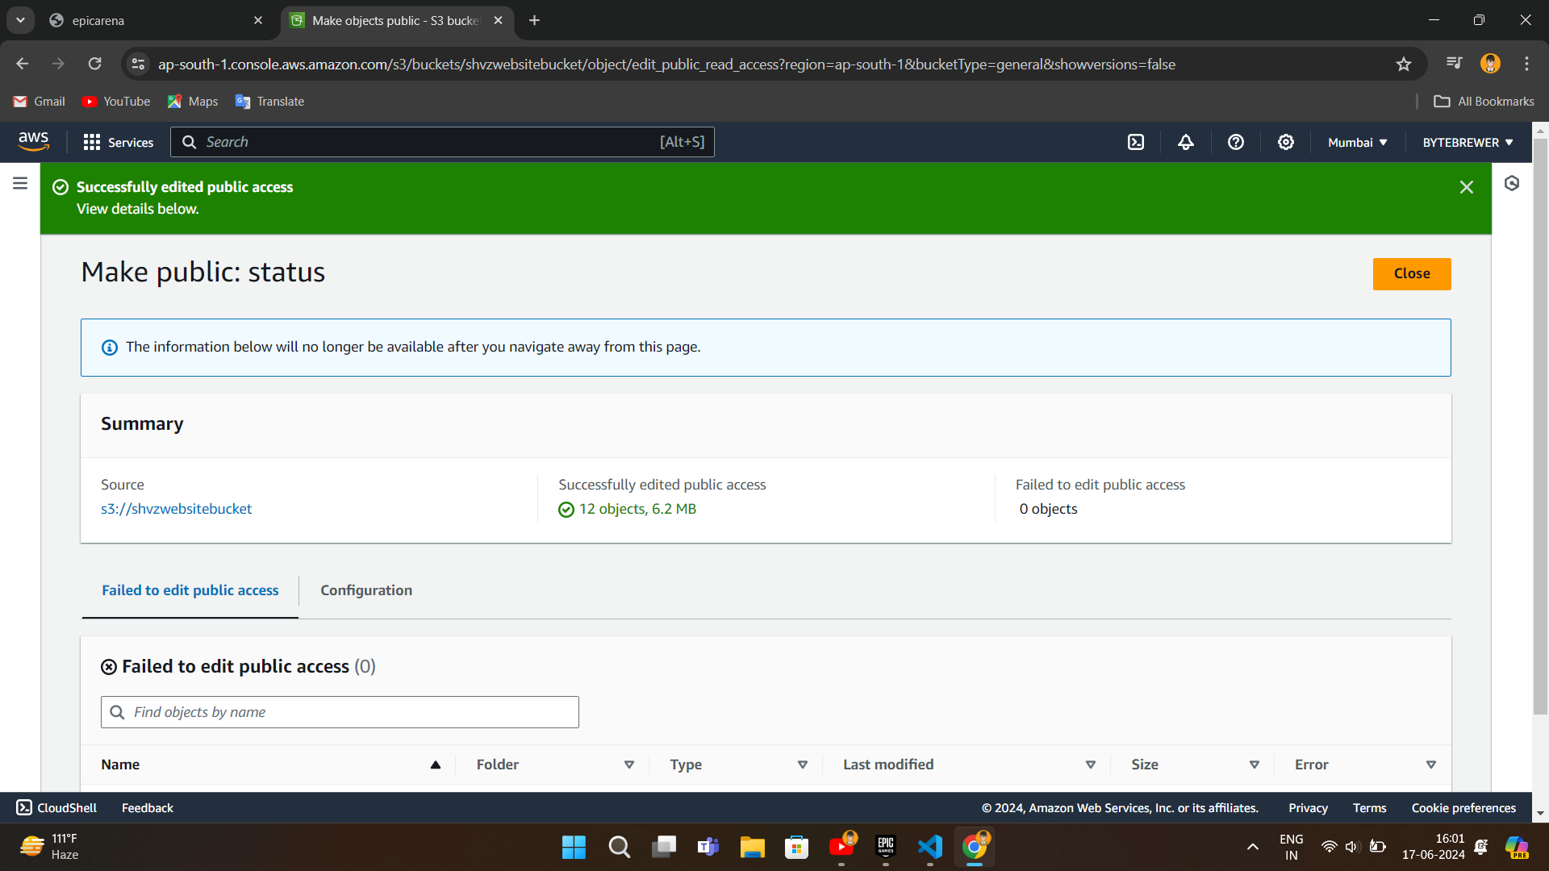

**STEP 4 :**

**Enable Website Hosting**

In order to serve assets via URL, you need to enable Website Hosting

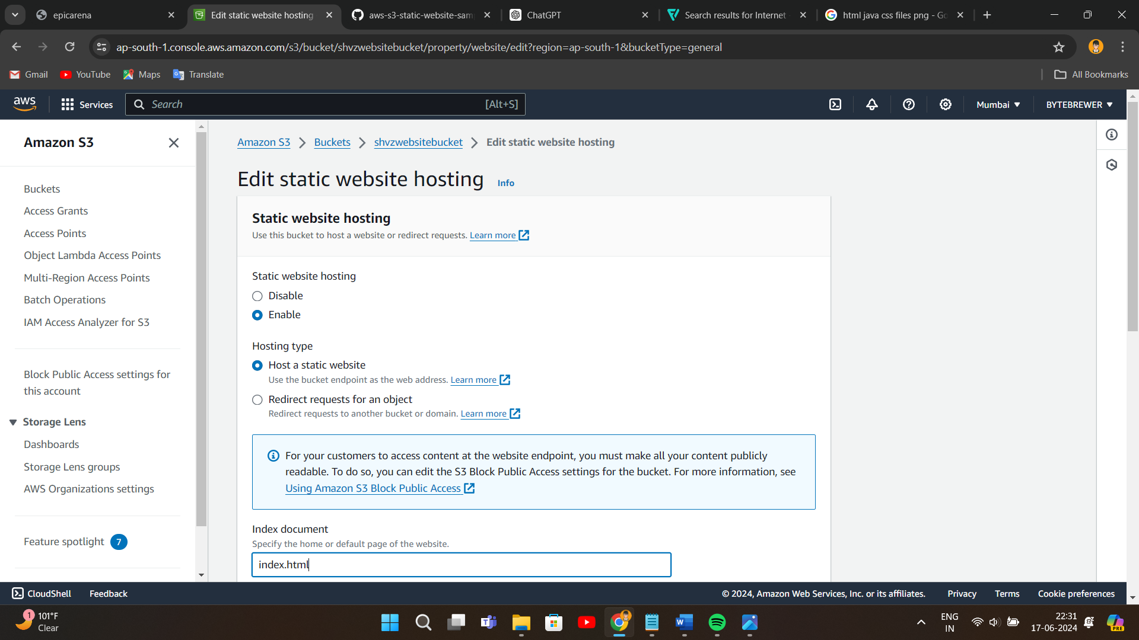Go to **Properties** and enable "***Static Website Hosting***" option

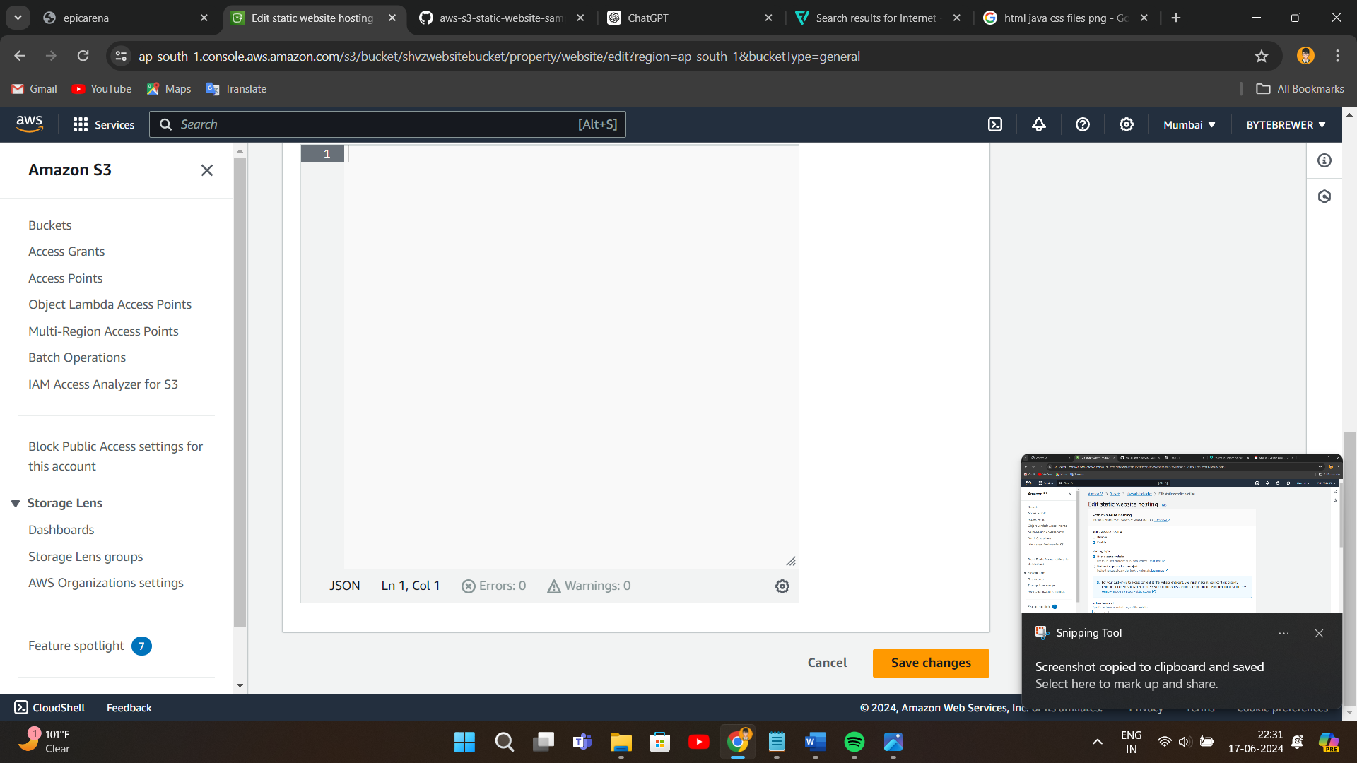

**STEP 5 :**

**Access Your Website**

* Go to your bucket and click on **index.html**
* Copy the **Object URL**
* Access the site in Browser using the Object URL

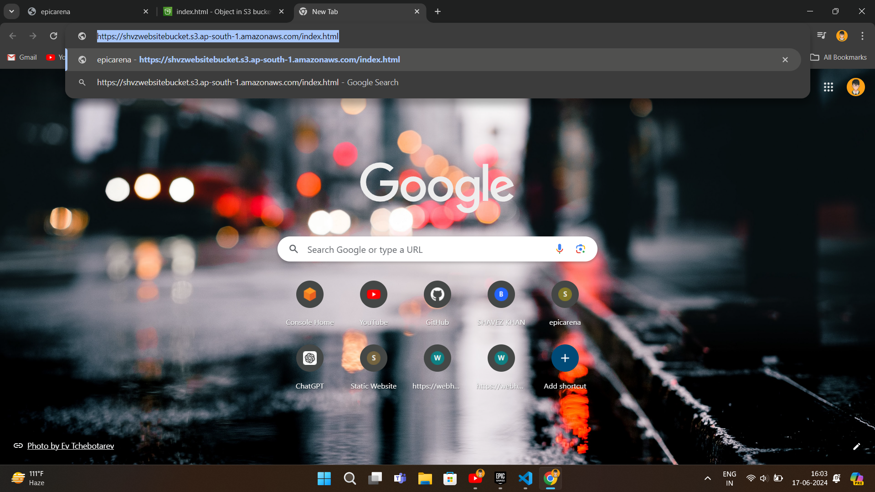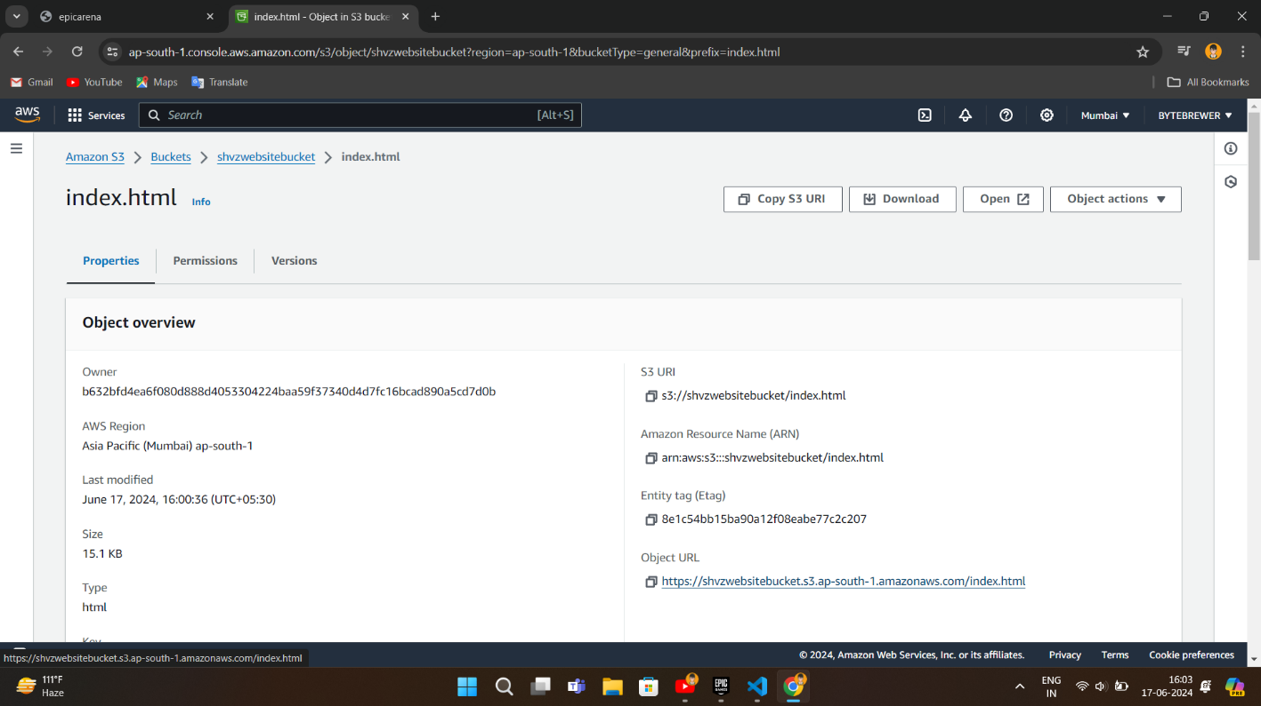

* Hit the URL and you’ll be redirected to your **Website**





**6. CONCLUSION**



We successfully created a static website using Amazon S3. By leveraging S3's robust features such as high scalability, security, and cost-effectiveness, we were able to efficiently host a static site without the need for a traditional server. The process involved setting up an S3 bucket, configuring it for website hosting, and managing access permissions. This project demonstrated the practical advantages of using Amazon S3 for static website hosting, highlighting its simplicity, reliability, and powerful integration capabilities within the AWS ecosystem.

**7. REFERENCES**





* [What is Amazon S3](https://docs.aws.amazon.com/AmazonS3/latest/userguide/Welcome.html)
* [Difference between Static and Dynamic website](https://blog.hubspot.com/website/static-vs-dynamic-website)
* [Hosting a Static Website on Amazon S3](https://docs.aws.amazon.com/AmazonS3/latest/userguide/WebsiteHosting.html)